Customer Enrollment Center for SAP Service Cloud Version 2

Solution Design Document
Custom Extension and Integration Solution using SAP Service Cloud V2, SAP BTP and SAP S/4HANA Utilities

Prepared By
Jamparaju Nammi

Attribute | Value
Document Title | Customer Enrollment Center for SAP Service Cloud V2 – Solution Design
Version | 1.0
Date | 08 July 2026
Audience | Business stakeholders, Enterprise/Solution Architects, Integration and Development teams

1. Executive Summary
The Majority of Utilities currently offering lot of energy programs to customers (Demand response programs Peak-Time Rebate, Critical Peak Pricing, Deferred Payment Plan, PrePay, Customer Selects Due Date and similar offerings, TOU rates) through an Enrollment Center built in the legacy SAP CRM Interaction Center. With the move of the agent desktop to SAP Service Cloud Version 2 (SC V2), this capability must be re-established, because SC V2 does not deliver a standard Enrollment Center for utilities customer programs.
This document proposes a side-by-side extension: a custom Enrollment Center application built and hosted on SAP Business Technology Platform (BTP), embedded directly in the SC V2 agent desktop, and integrated with SAP S/4HANA Utilities through SAP Integration Suite and SAP Event Mesh. S/4HANA Utilities remains the single system of record for business partner, contract account, premise, installation, device, contract and billing-relevant data; BTP owns orchestration, eligibility rules facade, enrollment workflow, audit and exception routing; SC V2 remains the interaction and case-management layer.
The solution framework, the Enrollment Center is reachable from two access points inside Service Cloud V2: (1) in-screen as a step of the Customer Move-In guided process, so program offers are made while the new contract is being created; and (2) as a dedicated work center (mashup) for all enrollment scenarios on active contracts of existing customers. Both access points render the same BTP application and consume the same APIs — only the entry context differs.
The design deliberately re-uses the proven functional model of the legacy Enrollment Center if any — Participating Programs, Available (Eligible) Programs, Eligibility Messages with hard-stop and warning severity, and Program History — while re-platforming it on a clean-core, API-first architecture that keeps the S/4HANA digital core free of UI-specific custom code and allows new programs to be onboarded through configuration and rules rather than new development.
Key outcomes:
- Single agent desktop: agents enroll, de-enroll and track customer programs without leaving SAP Service Cloud V2.
- Centralized eligibility: one rules layer evaluated for all programs in a single call, with reasons returned for ineligible programs.
- Clean core: no Enrollment Center UI code inside S/4HANA; backend accessed only through released APIs and governed custom services.
- Scalability: onboarding a new program requires a rule set, a program configuration entry and (where needed) one backend automation — not a new user interface.
- Traceability: every enrollment request, status change and exception is audited end-to-end and visible to agents and supervisors.

2.User stories for Enrollment Center

Story ID | Title | User Story | Acceptance Criteria (Given / When / Then)
Epic 1: Customer Context & Access (Work Center)
US-01 | Open Enrollment Center from Case / Customer 360 | As a Enrollment Agent  I want to open the Enrollment Center directly from the customer/case workspace  So that I don't have to re-search or re-authenticate the customer | Given an agent is on an active case with an identified business partner and contract account  When the agent opens the Enrollment Center work center or tab  Then the Enrollment Center loads with signed context (business partner ID, contract account, case ID, agent ID)  And the agent is not prompted to search for or re-identify the customer
US-02 | Fast Context and Eligibility Load | As a Enrollment Agent  I want the customer's program participation and eligibility data to load quickly  So that I can serve the customer without dead air on the call | Given the Enrollment Center is opened for a typical account  When context and eligibility data are retrieved from S/4HANA Utilities  Then all four panels (Participating, Available, Eligibility Messages, Program History) render within approximately 3 seconds  And the agent does not need to manually trigger the eligibility check
Epic 2: Program Participation & Eligibility Visibility
US-03 | View Participating Programs | As a Enrollment Agent  I want to see all programs the customer currently participates in, with status and dates  So that I can give the customer an accurate program overview in one glance | Given the customer has one or more program participations  When the Participating Programs panel loads  Then each program shows its lifecycle status (e.g., Enrollment Request, Enrollment Pending, Enrolled), the request date, and the actual enrollment date  And Program Status is displayed as read-only, never as an editable dropdown
US-04 | View Available (Eligible) Programs | As a Enrollment Agent  I want to see the programs the customer is eligible for, presented as hyperlinks  So that I can quickly review and offer relevant programs to the customer | Given the eligibility evaluation has completed for the customer  When the Available Programs panel renders  Then each eligible program appears as a hyperlink  And one click opens the program description and terms  And a second click starts the program's guided enrollment steps
US-05 | View Eligibility Messages with Hard-Stop / Warning Severity | As a Enrollment Agent  I want to see why a customer is ineligible for a program, with the reason classified as a hard stop or a warning  So that I can explain the situation to the customer or determine whether a supervisor override is possible | Given a program fails one or more eligibility rules for the customer  When the Eligibility Messages panel renders  Then each message is labeled as either Hard Stop or Warning  And programs with a Hard Stop cannot be selected for enrollment  And programs with only Warning-level messages can proceed via the supervisor-approval path
US-06 | View Program History | As a Enrollment Agent  I want to see the customer's past program enrollments and outcomes  So that I can discuss history with the customer and rely on the system to enforce rules like re-enrollment waiting periods | Given the customer has one or more past enrollments or de-enrollments  When the Program History panel loads  Then start date, end date, and outcome are shown for each historical record  And the eligibility engine automatically applies waiting-period and other history-based rules without agent intervention
Epic 3: Enrollment Initiation & Capture
US-07 | Start Enrollment into a Program | As a Enrollment Agent  I want to initiate enrollment into an eligible program  So that I can capture the required program-specific data in a guided flow | Given a program is shown as eligible in the Available Programs panel  When the agent selects the program and chooses Enroll  Then a guided capture form specific to that program renders (e.g., start date, plan parameters, device details, consent statements, document upload)
US-08 | Capture Only Program-Specific Required Fields | As a Enrollment Agent  I want the capture form to show only the fields relevant to the selected program  So that data capture stays fast and accurate regardless of which program is being enrolled | Given a program's catalog entry defines its required inputs  When the capture form renders for that program  Then only the fields defined in the program catalog entry are displayed  And mandatory fields are enforced before the form can be submitted
Epic 4: Enrollment Submission & Validation
US-09 | Submit Enrollment Request with Immediate Feedback | As a Enrollment Agent  I want to submit an enrollment request and receive immediate validation feedback  So that I can confirm the outcome with the customer in the same call | Given the program-specific capture form has been completed  When the agent submits the enrollment  Then the Enrollment Service re-validates eligibility and enforces field/cross-field rules  And on success, the request is persisted with status Enrollment Request (Submitted), fully audited  And the agent receives confirmation or validation errors within the same interaction
US-10 | Block Submission on Hard-Stop Eligibility Failure | As a Enrollment Agent  I want the system to prevent submission when a hard-stop eligibility rule applies  So that ineligible enrollments are never created in the backend | Given a hard-stop condition applies to the selected program at the time of submission  When the agent attempts to submit the enrollment  Then the submission is rejected with the specific hard-stop reason displayed  And no enrollment request record is created
US-11 | Supervisor Override for Warning-Level Eligibility Failures | As a Supervisor  I want to approve or override a warning-level eligibility failure  So that an agent can proceed with a customer's enrollment when it is appropriate to do so | Given a selected program has only warning-level eligibility messages, no hard stops  When the agent requests to proceed with enrollment  Then the request routes to a supervisor for approval via SAP Build Process Automation  And upon supervisor approval, the enrollment proceeds to submission  And the override, approving supervisor, and reason are recorded in the audit trail
Epic 5: Fulfillment & Status Tracking
US-12 | Track Enrollment Status Through Backend Confirmation | As a Enrollment Agent  I want to see the enrollment status update through to backend confirmation  So that I can keep the customer informed without leaving SAP Service Cloud V2 | Given an enrollment request has been submitted and fulfillment has been dispatched  When S/4HANA Utilities confirms or rejects the change and emits a status event via Event Mesh  Then the Enrollment Center updates the status automatically (Enrolled, Enrollment Rejected, or Error – In Review)  And the linked SC V2 case/timeline reflects the latest status without the agent reopening the Enrollment Center
US-13 | Idempotent Submission on Retry | As a Enrollment Service  I want enrollment submissions to be idempotent  So that a network failure or client retry never creates a duplicate enrollment | Given an enrollment submission is retried after a timeout or connectivity failure  When the Enrollment Service receives the duplicate submission  Then it recognizes the idempotency key from the original request  And it does not create a second enrollment record or dispatch a second fulfillment recipe
Epic 6: De-Enrollment
US-14 | Initiate One-Click De-Enrollment | As a Enrollment Agent  I want to de-enroll a customer from a participating program with one click  So that I can quickly action a customer's de-enrollment request | Given a program is listed in the Participating Programs panel  When the agent selects De-enroll  Then the system validates exit rules (minimum participation period, outstanding balances, pending device work)  And the agent is prompted to capture a reason code  And on confirmation, status is set to De-enrollment Request / Pending De-enrollment
US-15 | Block De-Enrollment on Failed Exit Rules | As a Enrollment Service  I want de-enrollment to be blocked when exit rules are not satisfied  So that program terms and any outstanding customer obligations are respected | Given an outstanding balance exists on a payment-plan program the customer wants to exit  When the agent attempts to de-enroll the customer  Then the de-enrollment is blocked  And the specific blocking reason is shown to the agent
Epic 7: Move-In Embedded Enrollment
US-16 | Offer Programs During Customer Move-In | As a Enrollment Agent  I want to offer eligible programs during the Move-In guided process  So that new customers can be enrolled at the natural moment their contract is being created | Given the agent has reached the Customer Programs step of the Move-In guided process  When the Enrollment Center renders in move-in (pre-active) context  Then eligibility is evaluated using the prospective premise, installation/device, and customer data  And rules that require billing history return “not yet eligible” rather than a hard failure
US-17 | Automatic Fulfillment on Contract Activation | As a Enrollment Service  I want enrollment requests captured during Move-In to fulfill automatically once the contract activates  So that agents don't need to re-enroll customers after the move-in completes | Given one or more programs were selected during Move-In with status Enrollment Request  When the move-in completed / contract activated event is received via Event Mesh  Then eligibility is automatically re-validated on the now-active contract  And fulfillment recipes are dispatched automatically, advancing status to Enrollment Pending
US-18 | Cancel Move-In Cascades to Linked Enrollment Requests | As a Enrollment Service  I want linked Enrollment Requests to be cancelled automatically if a Move-In is cancelled before activation  So that no orphaned enrollment requests remain in the system | Given a move-in document has one or more linked Enrollment Request records  When the move-in is cancelled before contract activation  Then all linked Enrollment Requests are cancelled automatically  And the cascade is recorded in the audit trail
Epic 8: Exception Handling & Supervisor Cockpit
US-19 | Route Technical Failures to the Exception Queue | As a Integration Platform  I want failed fulfillment messages to route to a supervisor exception queue once retries are exhausted  So that no enrollment is ever silently lost due to a technical error | Given a fulfillment message fails after exponential-backoff retries  When the retry budget is exhausted  Then the message is placed on a dead-letter queue  And the enrollment status is set to Error – In Review  And the item appears in the supervisor's exception inbox with context and error detail
US-20 | Resolve an Enrollment Exception | As a Supervisor  I want to retry, correct-and-resubmit, or cancel an enrollment that is in Error – In Review  So that I can resolve exceptions directly without engaging development support | Given an enrollment item is in Error – In Review in the supervisor inbox  When the supervisor selects Retry, Correct-and-Resubmit, or Cancel  Then the corresponding action is executed against the enrollment  And if Cancel is chosen, a customer callback task is created in SC V2  And the resolution, actor, and timestamp are recorded in the audit log
US-21 | Reconcile Pending Backend Enrollments | As a Enrollment Service  I want a scheduled job to reconcile Pending Backend enrollments against S/4HANA state  So that enrollments with missed confirmation events are caught rather than aging silently | Given an enrollment has remained in Pending Backend status beyond the expected processing window  When the scheduled reconciliation job runs  Then it compares the BTP-held state against the actual S/4HANA Utilities state  And it raises an exception for any discrepancy found, routing it to the supervisor inbox
Epic 9: Audit, Security & Compliance
US-22 | Audit Every Enrollment Action | As a Compliance / Audit Stakeholder  I want every eligibility evaluation, submission, status change, and override to be recorded  So that enrollment activity is fully traceable for regulators and program compliance reviews | Given any enrollment-related action occurs (evaluation, submission, status change, override)  When the action completes  Then actor, timestamp, channel, and a payload hash are persisted in HANA Cloud  And the full audit history is retrievable for any given enrollment or customer
US-23 | Enforce Role-Based Access | As a Enrollment Admin  I want agents, supervisors, and admins to have distinct, enforced permissions  So that sensitive actions such as warning overrides and catalog changes are restricted to the appropriate role | Given a user is assigned only the Enrollment Agent role collection  When the user attempts a supervisor-only action, such as a warning-level override  Then the action is denied  And only users holding the Enrollment Supervisor or Enrollment Admin role collection can perform it

3. Business Requirement

3.1 Background
Call center agents (CSRs) are the primary channel for enrolling customers into utility programs. In the legacy CRM Interaction Center, the Customer Programs Enrollment Center gave agents a 360° view of a customer's program participation and one-click enrollment/de-enrollment with system-driven eligibility.
Prior option analysis (standalone Enrollment Center vs. Move-In integration vs. no Enrollment Center) concluded that the absence of an Enrollment Center drives high scalability, training and call-handling impacts. The same conclusion applies to the SC V2 landscape: without an equivalent capability, agents would need to swivel-chair into S/4HANA Utilities transactions, increasing handle time and error rates.

3.2 Requirement Statement
Call center agents working in SAP Service Cloud V2 shall be able to:
- Search and identify the customer and confirm the caller's identity and account (business partner, contract account, premise).
- View all programs the customer currently participates in, with status and effective dates.
- View all programs the customer is eligible for, and — for ineligible programs — the reasons, classified as hard stops or warnings.
- Initiate enrollment into a program, service, plan or device offering, capturing the required program-specific data (start date, plan parameters, device details, consents, documents).
- Submit the enrollment request and receive immediate validation feedback.
- Track enrollment status through to completion, including asynchronous backend confirmation.
- Initiate de-enrollment with the applicable exit rules and prompts.
- View enrollment history to support eligibility rules (e.g., re-enrollment waiting periods) and customer conversations.
- Access the Enrollment Center from two places: in-screen within the Customer Move-In guided process, and as a separate work center (mashup) for enrollment on active contracts.

3.3 Enrollment Scope
“Enrollment” covers any customer-elected utility offering that changes master data, contract terms or billing behavior in S/4HANA Utilities, including:
Category | Examples | Primary S/4HANA Utilities Object Affected
Demand response / rate programs | Peak-Time Rebate (PTR), Critical Peak Pricing (CPP), time-of-use rates | Utilities contract / rate category (product change), AMI device check
Payment programs | Deferred Payment Plan (DPP), budget billing, PrePay | FI-CA installment plan, budget billing plan, prepayment settings on contract account
Billing preferences | Customer Selects Due Date (CSDD), eBill / paperless billing | Contract account attributes, correspondence settings
Device / service offerings | Smart thermostat, EV charger program, AMR/AMI opt-in | Device / device info record, installation, service order
Assistance programs | Low-income assistance (DLA-type), medical alert | Contract account flags, dunning exemptions

3.4 Non-Functional Requirements
- Customer context, participation and eligibility must render within ~3 seconds of opening the Enrollment Center for a typical account.
- Eligibility for all programs must be evaluated in one round trip (parallelized in the backend), mirroring the legacy single BRF+ call for all programs and contract accounts.
- Enrollment submissions must be idempotent and survive backend downtime (queued, retried, never lost).
- All enrollment actions must be auditable: who, when, channel, before/after status.
- Role-based access: agents can enroll/de-enroll; supervisors additionally handle exceptions and overrides of warning-level eligibility failures. Hard stops cannot be overridden.

4. Solution Options Considered
Option | Description | Assessment
A. No Enrollment Center | Agents use standard SC V2 cases plus direct S/4HANA Fiori apps per program. | High click count and training effort, per-program eligibility prompts do not scale, no 360° program view — the same weaknesses identified for this option in the legacy CRM option scorecard.
B. Native SC V2 extensibility only | Model enrollment as SC V2 custom objects (extensibility) with autoflow-triggered integrations. | SC V2 low-code extensibility cannot host the required multi-step, rules-driven UI or complex orchestration; enrollment data would be mastered in the wrong system.
C. BTP side-by-side Enrollment Center (recommended) | Custom UI on BTP embedded in the SC V2 agent workspace; BTP services orchestrate eligibility, enrollment and status against S/4HANA Utilities via Integration Suite and Event Mesh. | Preserves the proven legacy Enrollment Center UX, keeps S/4HANA clean-core, scales to new programs via configuration + rules, and provides a single reusable enrollment API for future self-service channels (web/mobile/IVR).  Recommended

5. Proposed Architecture

5.1 Architecture Overview (Diagram Description)
The end-to-end architecture is a four-layer, left-to-right flow. Read the diagram as: agent desktop on the left, extension platform in the middle, digital core on the right, with an asynchronous event backbone underneath.
Layer | Components | Responsibility
1. Interaction Layer — SAP Service Cloud V2 | Agent desktop (Case Management, Customer Hub, CTI); Utilities industry add-on for customer identification; embedded Enrollment Center UI (mashup / custom UI integration); SC V2 REST APIs and autoflows | Call handling, customer identification, case creation, launching the Enrollment Center in customer context, displaying enrollment status on the case/timeline
2. Extension & Orchestration Layer — SAP BTP | Enrollment Center UI (SAP Build Apps or SAPUI5 on HTML5 Application Repository / SAP Build Work Zone); Enrollment Service (CAP on BTP Cloud Foundry); Eligibility Facade; SAP Build Process Automation (workflow + business rules); SAP HANA Cloud (enrollment staging, audit log); Destination, Connectivity, XSUAA/IAS | UI hosting, program catalog, eligibility orchestration, enrollment state machine, validation, workflow for exceptions/approvals, audit persistence, security
3. Integration Layer — SAP Integration Suite | Cloud Integration (iFlows), API Management, Event Mesh, Cloud Connector (if S/4HANA on-premise) | Protocol/format mediation (OData, SOAP, RFC/BAPI, IDoc), mapping, error handling and retry, API governance, throttling, async eventing
4. System of Record — SAP S/4HANA Utilities | Business partner, contract account (FI-CA), premise, installation, point of delivery, device, utilities contract, billing; BRF+ eligibility rule sets; BPEM (EMMA) case management; released OData/SOAP APIs, BAPIs, custom RFCs | Master data and contract truth, rate/product changes, installment and budget billing plans, device management, billing; enforcement of backend business rules; exception cases

Primary synchronous path: SC V2 agent desktop → embedded Enrollment Center UI (BTP) → Enrollment Service APIs (BTP, exposed via API Management) → Cloud Integration iFlows → S/4HANA Utilities APIs/BAPIs. Primary asynchronous path: S/4HANA Utilities business events / IDoc status → Event Mesh → Enrollment Service (status update, audit) → SC V2 case/timeline update via SC V2 REST API.
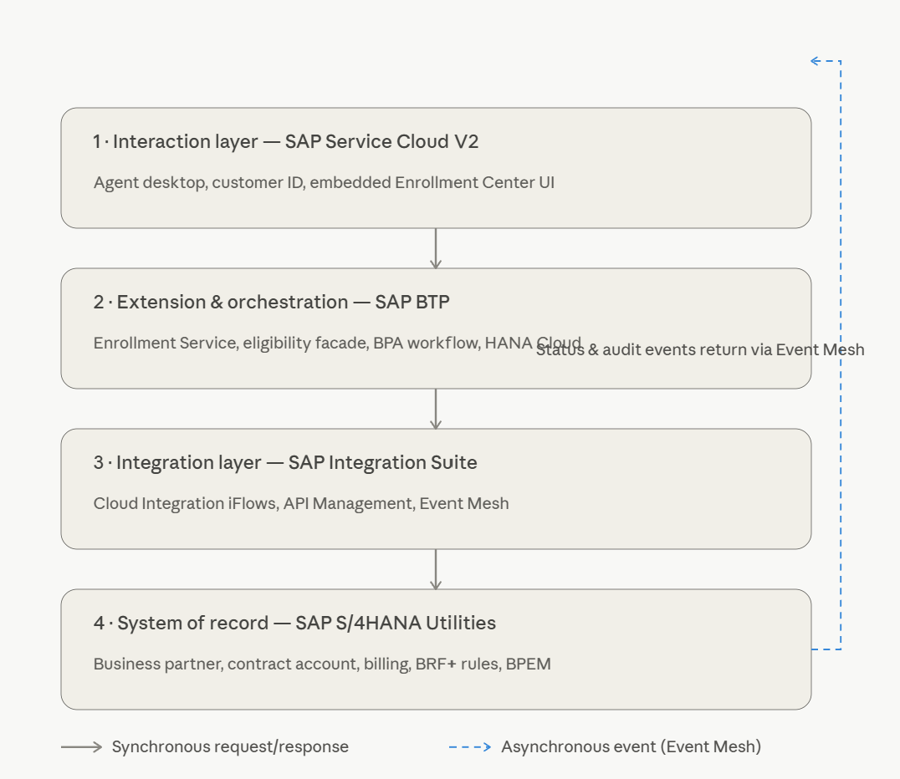

5.2 Design Principles
- Clean core — no Enrollment Center UI or orchestration logic inside S/4HANA; only rule sets, released APIs and thin, governed custom function modules (re-using existing objects such as the program eligibility pre-check RFC and rate category services from the legacy build).
- System of record unchanged — enrollment outcomes always materialize as standard S/4HANA Utilities objects (product/rate change, installment plan, contract account attributes, device/service order). BTP persists only process state and audit, never master data.
- One eligibility service — a single eligibility API evaluates all programs for all of a customer's contract accounts in one call, returning eligible programs and per-program failure reasons with severity (hard stop vs. warning) — the same contract as the legacy BRF+ design.
- Configuration over code — programs are catalog entries (name, description, required inputs, eligibility rule set ID, fulfillment recipe) so new programs avoid UI change.
- Channel-agnostic services — the same enrollment APIs can later serve customer self-service web/mobile, IVR and field mobile without rework.

5.3 Access Points in Service Cloud V2
The Enrollment Center is one BTP-hosted application surfaced at two access points, per the Solution Framework: standalone for all scenarios on active contracts, and embedded in the Move-In guided process for new contracts.
Access Point | SC V2 Integration Technique | Entry Context | Scope of Actions
1. Customer Move-In (in-screen) | Embedded step/panel inside the Move-In guided flow (external application integration within the process screen) | Business partner, prospective premise/installation, move-in document ID, requested start date — contract not yet active | Offer and capture enrollments in 'pre-active' mode: eligibility evaluated on prospective data; requests stored with status Enrollment Request and fulfilled automatically when the move-in completes (Section 5.3)
2. Enrollment Center work center (mashup) | Dedicated work center / navigation entry rendering the Enrollment Center as a mashup with signed context handover | Identified customer with active contract account(s) — all divisions | Full capability: enroll, de-enroll, status tracking, history — on active contracts only, consistent with the framework decision

Both access points call identical APIs; the UI adapts by context flag (moveIn vs. standalone). This guarantees one rules engine, one status model and one audit trail regardless of where the agent works.

5.4 Enrollment Center UI — Four Main Components
The UI implements the four components defined in the Solution Framework:
- Participating Programs — all enrolled programs listed with a one-click De-enroll button that launches the program-specific de-enrollment steps/prompts. Program Status is display-only (not a CSR dropdown) and shows the lifecycle state — e.g., Enrollment Request, Enrollment Pending, Enrollment Rejected, Enrolled. Both the enrollment request date and the actual program enrollment date are shown, giving insight into the customer lifecycle across programs.
- Available Programs — eligible programs presented as hyperlinks: one click opens the program information (description, terms), one click starts the enrollment with the program-specific guided steps.
- Eligibility Messages — customer-specific eligibility details per program — e.g., 'requires de-enrollment from another program first' — classified as hard stops (block enrollment) or warnings (agent may proceed, optionally with supervisor approval).
- Program History — maintained enrollment history (program, start/end dates, outcome) used both for customer conversation and as input to process/system eligibility rules such as re-enrollment waiting periods.
Before the Enrollment Center is displayed, the eligibility check runs for all programs (single batched call), so the four panels render complete on first paint — the agent never triggers eligibility manually.
Technology choice: SAPUI5/Fiori Elements (TypeScript) hosted in the HTML5 Application Repository is recommended for the agent UI because of the guided multi-step capture, complex table interactions and theming alignment with SC V2 (Horizon). SAP Build Apps remains a viable low-code alternative if the client prioritizes citizen-development ownership; the API layer is identical in both cases.
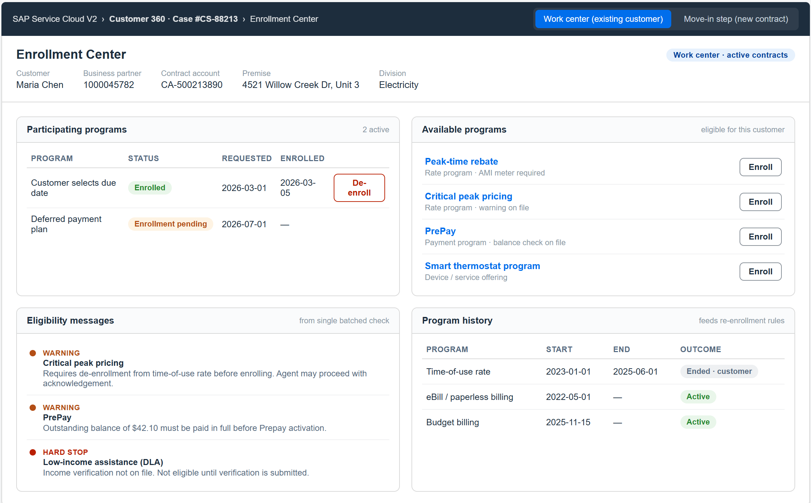

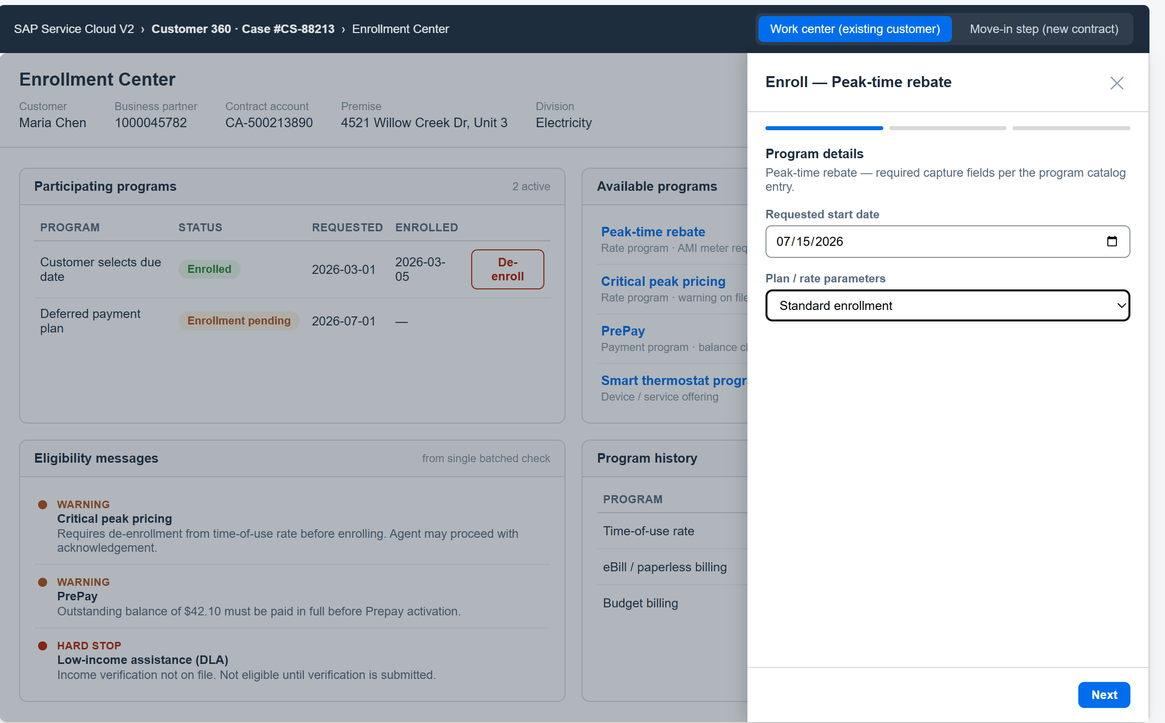

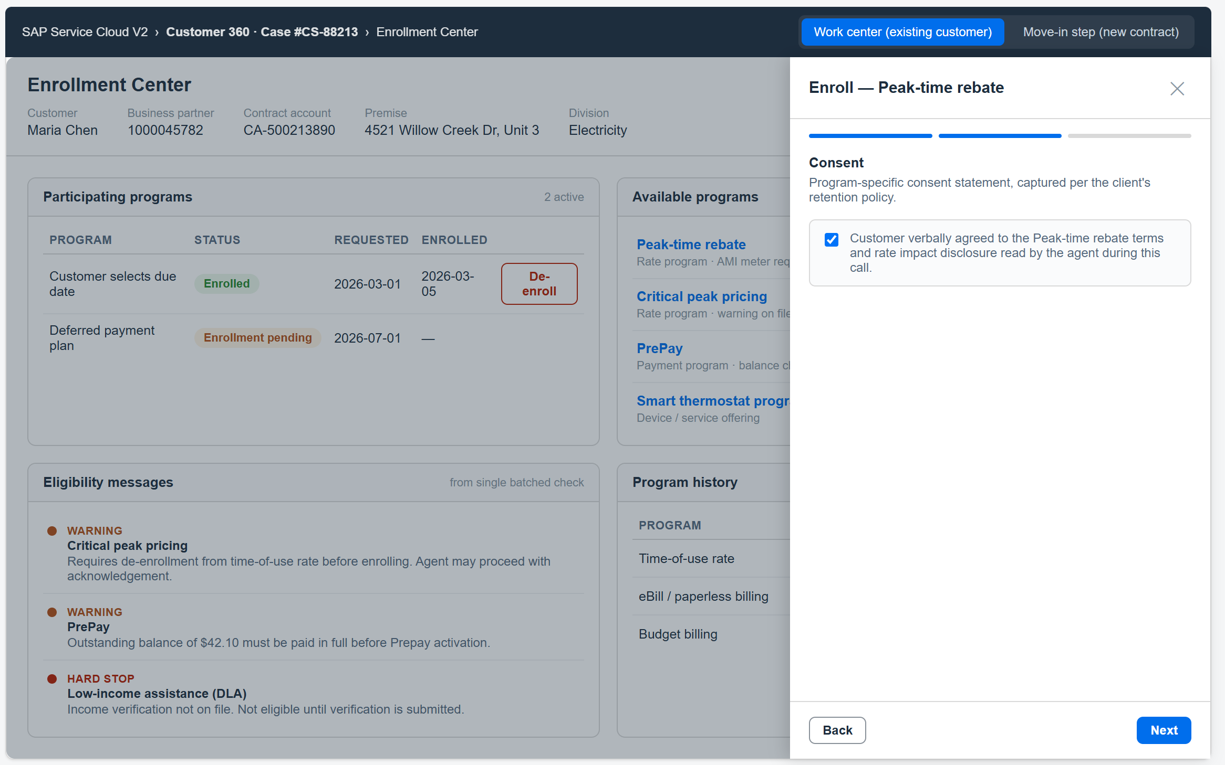

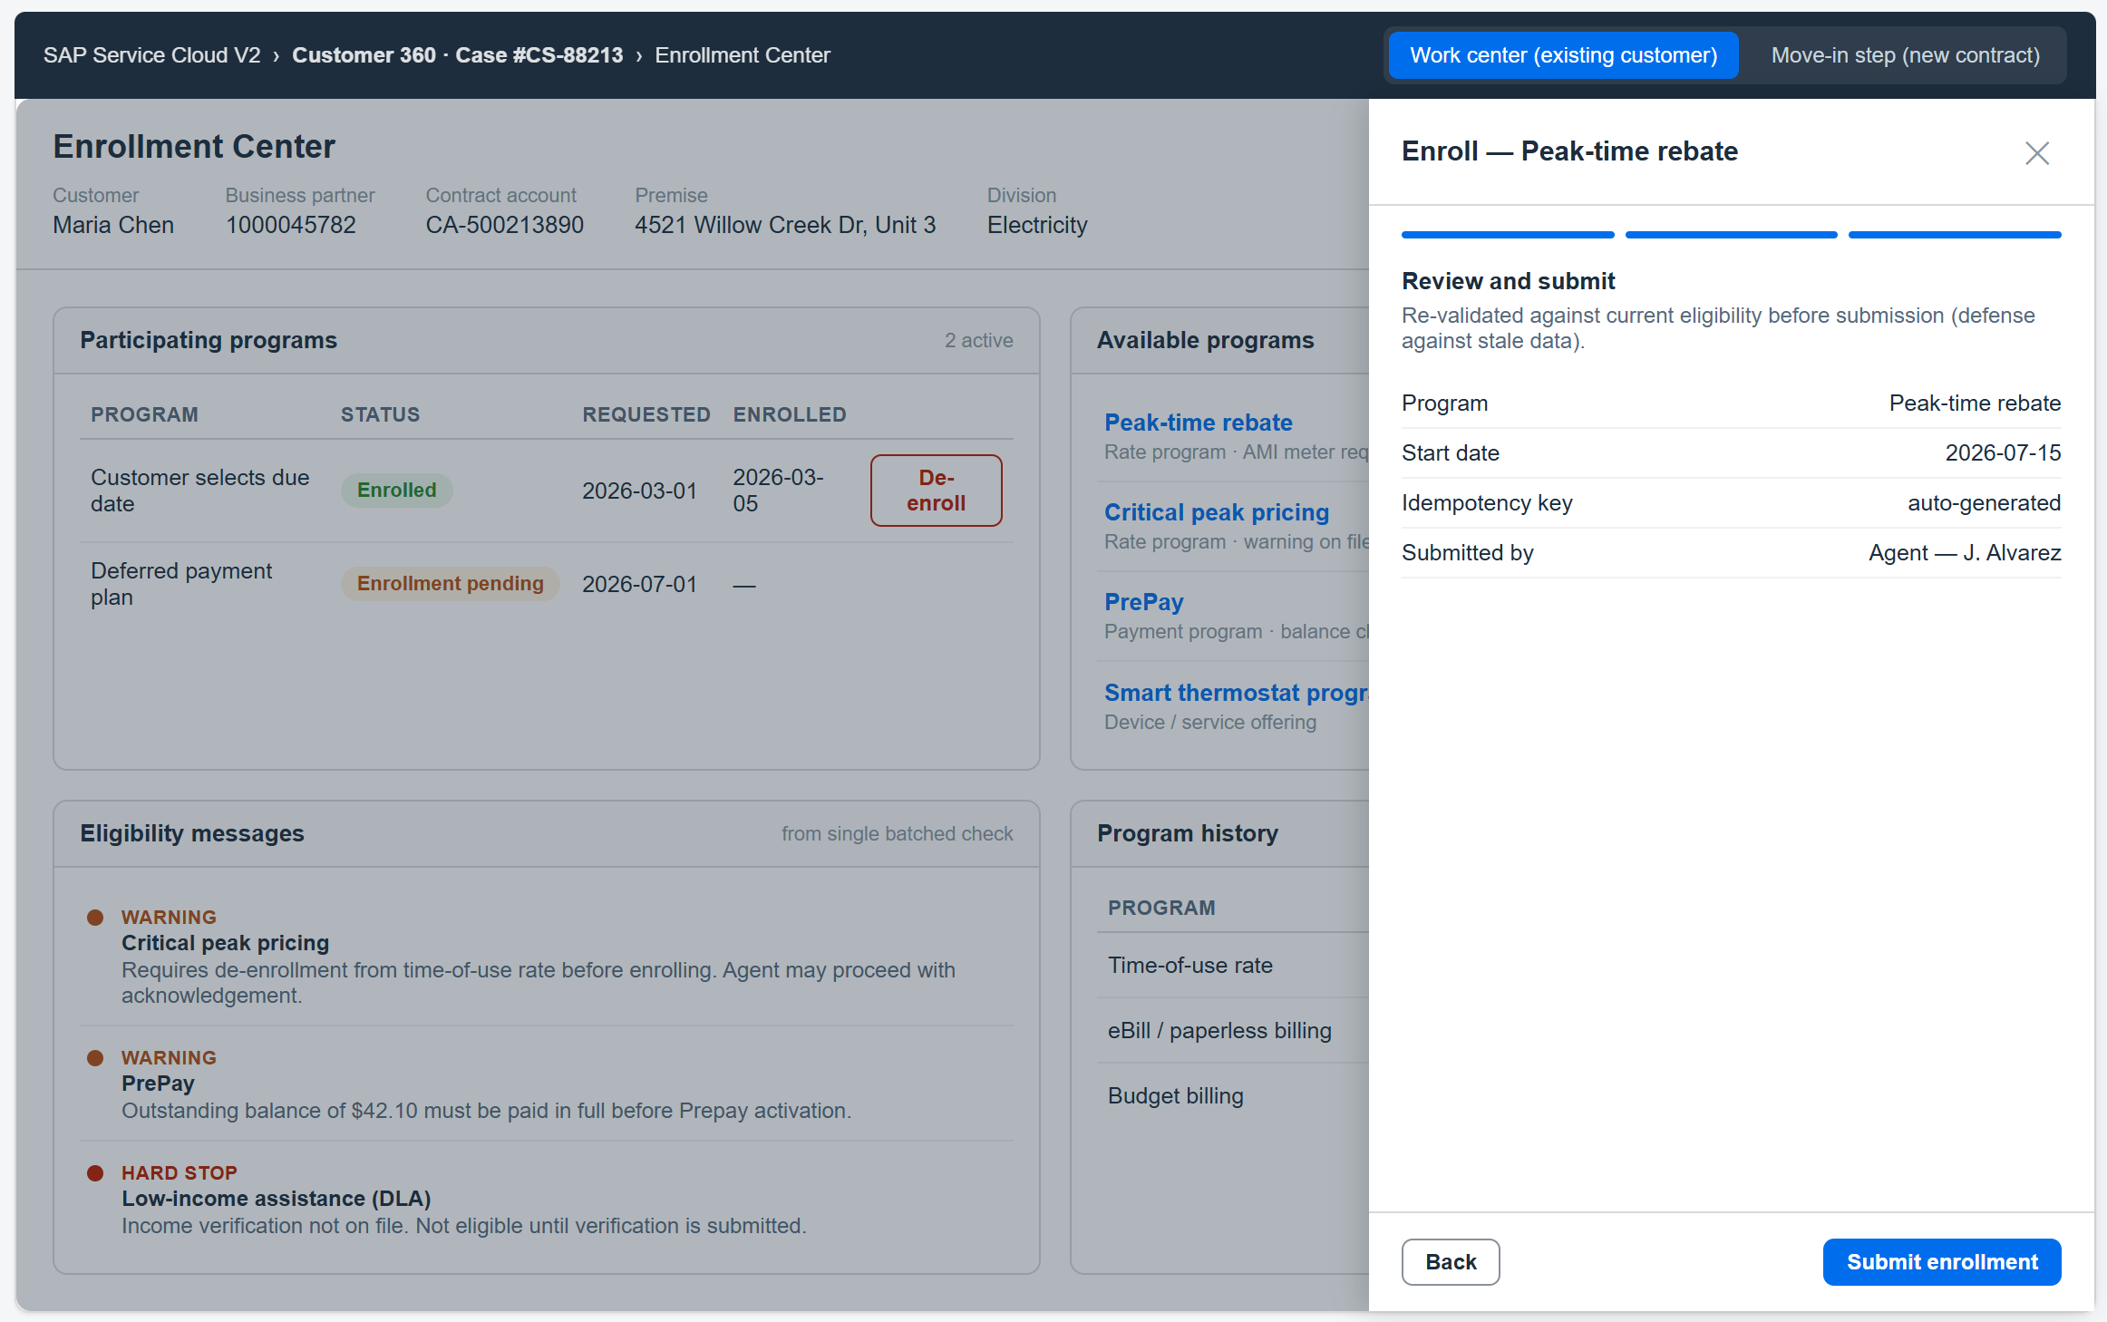

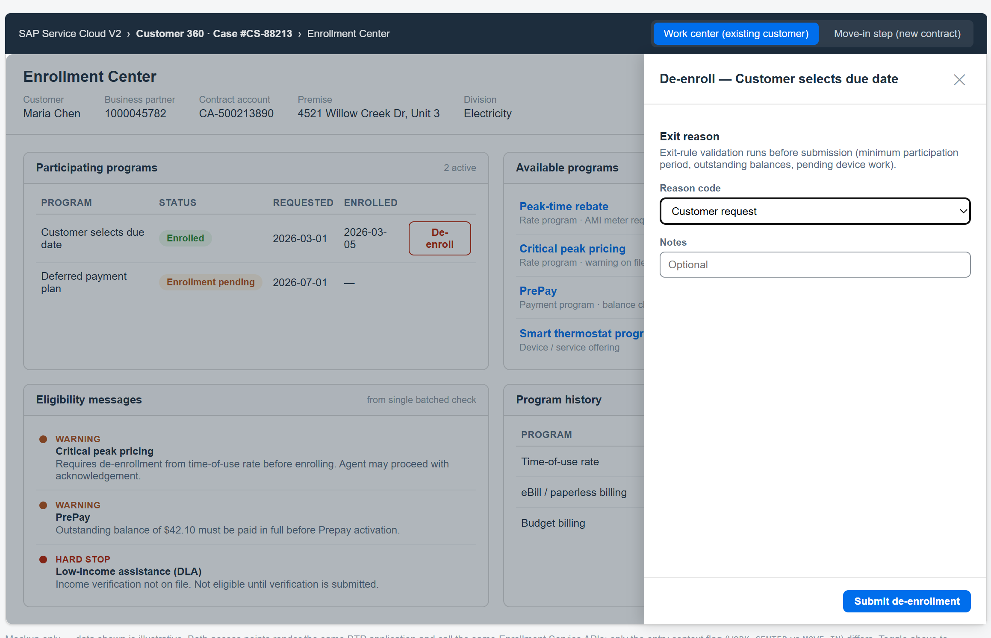

6. Functional Process Flow

6.1 Main Flow: Standalone Enrollment During a Call (Work Center Access)
- Call arrives — CTI screen-pop in SC V2 identifies the caller; the agent confirms identity. A case/interaction is created (or continued) in SC V2.
- Agent opens the Enrollment Center from the customer/case workspace. SC V2 passes context (business partner ID, contract account, case ID, agent ID) to the embedded BTP UI via URL/token parameters.
- Context load — the Enrollment Service retrieves customer, premise, installation, point of delivery, device, contract and contract account data from S/4HANA Utilities (read iFlows), plus current participation and history.
- Eligibility check — one call to the Eligibility API evaluates all programs for all contract accounts (S/4HANA BRF+ rule sets via RFC facade, optionally supplemented by BTP-side rules for channel/campaign logic). The UI renders Participating, Available and Eligibility Message panels.
- Agent advises the customer and selects a program; the UI presents the program-specific capture form (start date, plan terms, device details, consent statements, document upload where required).
- Submit — the Enrollment Service re-validates eligibility (defense against stale data), enforces field and cross-field rules, persists the enrollment request (status: Submitted) with full audit, and acknowledges the agent within the same interaction.
- Fulfillment — Cloud Integration executes the program's fulfillment recipe against S/4HANA Utilities (e.g., product/rate change on the utilities contract, FI-CA installment plan creation for DPP, contract account attribute update for CSDD, service order for device programs). Simple recipes run synchronously; long-running ones run asynchronously with the request set to Pending Backend.
- Confirmation — S/4HANA emits a business event / status message consumed via Event Mesh; the Enrollment Service sets the status to Enrolled (or Rejected/Error) and records actual effective dates.
- Agent visibility — the Enrollment Center refreshes in place; the Enrollment Service also writes a timeline/case update back to SC V2 so status is visible without reopening the Enrollment Center.
- Wrap-up — the agent completes the case; enrollment reference and status remain linked to the SC V2 case for future interactions and reporting.

6.2 De-enrollment Flow
From Participating Programs, the agent triggers De-enroll. The service validates exit rules (minimum participation period, outstanding balances for payment plans, pending device work), captures the reason code, sets the record to Pending De-enrollment and executes the reversal recipe in S/4HANA (e.g., product change back to standard rate, plan deactivation). Confirmation follows the same event-driven status path.

6.3 Move-In Flow: In-Screen Enrollment During New Contract Creation
A dedicated Customer Programs step is added to the Move-In guided process (mirroring the legacy CM integration option in the Solution Framework). Because standalone enrollment operates on active contracts only, move-in enrollments use deferred fulfillment:
- Agent completes the core move-in capture (premise, start date, contract/meter data) in SC V2.
- The Customer Programs step renders the embedded Enrollment Center in move-in context: eligibility is evaluated in pre-active mode using the prospective premise, installation/device and customer data (rules that require billing history simply return 'not yet eligible').
- Agent offers eligible programs and captures enrollment selections with program-specific data; each selection is stored with status Enrollment Request, linked to the move-in document ID.
- Move-in is submitted; S/4HANA Utilities creates the contract(s) and contract account.
- On the move-in completed / contract activated event (Event Mesh), the Enrollment Service automatically re-validates eligibility on the now-active contract and dispatches the fulfillment recipes; statuses advance to Enrollment Pending.
- Confirmations return as in the standalone flow (Enrolled with actual enrollment date, or Enrollment Rejected with reason routed to the agent's follow-up case).
If the move-in is cancelled before activation, linked Enrollment Requests are cancelled automatically and the audit trail records the cascade.

6.4 Enrollment Status Model
Status values follow the Solution Framework naming; Program Status in the UI is display-only, never an agent-editable dropdown.
Status | Set By | Meaning
Draft | Enrollment UI | Data capture in progress; not yet submitted.
Enrollment Request | Enrollment Service | Request validated, accepted and audited (request date recorded). In move-in context: parked until contract activation.
Enrollment Pending | Enrollment Service | Fulfillment recipe dispatched to S/4HANA Utilities; awaiting backend confirmation.
Enrolled | S/4HANA event | Backend object created/changed; actual program enrollment date recorded.
Enrollment Rejected | Eligibility / S/4HANA | Hard-stop failure at submit, backend rejection, or failed re-validation at contract activation — always with reason.
Error – In Review | Integration layer / workflow | Technical or data error routed to exception workflow (see Section 9).
De-enrollment Request / Pending | Enrollment Service | De-enrollment submitted; exit steps executed; awaiting backend confirmation.
De-enrolled / Ended | S/4HANA event | Participation ended; end date recorded in Program History.

7. Integration Design

7.1 SC V2 ↔ Enrollment Center UI (Both Access Points)
- Work center access: the Enrollment Center is registered as a mashup / external application rendered in a dedicated work center (and optionally as a tab on Customer 360 and Case screens), receiving signed context (business partner, contract account, case ID) — no re-search by the agent.
- Move-in access: the same application is embedded in-screen as the Customer Programs step of the Move-In guided process; context additionally carries the move-in document ID and prospective premise/installation so the UI switches to pre-active mode with deferred fulfillment (Section 5.3).
- Single sign-on via SAP Cloud Identity Services (IAS): the agent's SC V2 identity propagates to the BTP UI and APIs (OAuth2/OpenID Connect), so all actions are performed and audited under the agent's named user.
- The Enrollment Service writes status updates back to SC V2 via its public REST APIs (case update / timeline entry); optionally SC V2 autoflows react to incoming status to trigger follow-up tasks or customer notifications.

7.2 BTP Enrollment Service APIs
A CAP-based Enrollment Service exposes the functional API consumed by the UI (and future channels), published and governed through API Management. See Section 8 for the full API list.

7.3 Integration Suite ↔ S/4HANA Utilities
- Released OData APIs are used wherever available (business partner, contract account/FI-CA, utilities contract and premise/connection data via released CDS-based services).
- SOAP services and BAPIs/RFCs (via Cloud Connector where on-premise) cover utilities-specific operations without released OData equivalents — e.g., move-in/product change BAPIs, budget billing/installment plan functions, and re-use of existing custom RFCs from the legacy build such as the program eligibility pre-check function module and rate category eligibility services.
- IDocs remain acceptable for high-volume asynchronous confirmations where the client already operates IDoc monitoring; otherwise business events via Event Mesh are preferred.
- Where no standard API exists (e.g., program-specific enrollment tables), a thin custom OData/RFC service is built in S/4HANA following the client's WRICEF governance — kept UI-agnostic so it serves all channels.

7.4 Event Mesh (Asynchronous Backbone)
- S/4HANA Utilities business events (contract created/changed, move-in completed, installment plan created, BPEM case closed) are published to Event Mesh topics.
- The Enrollment Service subscribes to update enrollment status, write audit entries and push SC V2 case updates — decoupling agent experience from backend processing time.
- Dead-letter queues plus redelivery policies guarantee no lost confirmations; unprocessable events route to the exception workflow.

7.5 Integration Flow Inventory
# | Flow | Direction | Style / Protocol | Purpose
IF-01 | Customer Context Read | BTP → S/4 | Sync OData (parallelized reads) | BP, contract account, premise, installation, PoD, device, contract snapshot for the Enrollment Center
IF-02 | Eligibility Check | BTP → S/4 | Sync RFC/OData facade to BRF+ rule sets | All programs × all contract accounts in one call; returns eligible list + failure reasons with severity
IF-03 | Enrollment Fulfillment | BTP → S/4 | Sync or async per recipe (BAPI/OData/SOAP) | Product/rate change, installment plan, contract account update, service order, prepay activation
IF-04 | De-enrollment Fulfillment | BTP → S/4 | Sync or async per recipe | Reversal recipes with exit-rule validation
IF-05 | Status Confirmation | S/4 → BTP | Async events (Event Mesh) / IDoc status | Enrollment/de-enrollment outcome, actual dates, BPEM case references
IF-06 | SC V2 Case Update | BTP → SC V2 | Sync REST | Timeline/status write-back to the case
IF-07 | Document Store | BTP internal / DMS | Sync REST/CMIS | Consent forms and supporting documents linked to the enrollment record
IF-08 | Exception Routing | Any → BTP workflow | Async | Failed validations/fulfillments to SAP Build Process Automation inboxes
IF-09 | Move-In Activation Trigger | S/4 → BTP | Async event (Event Mesh) | Move-in completed / contract activated event releases parked Enrollment Requests for deferred fulfillment (re-validate + dispatch recipes)

8. API List

8.1 Enrollment Service APIs (BTP, consumed by UI / channels)
API | Method / Path | Description
Customer Context | GET /api/v1/customers/{bpId}/context | Aggregated snapshot: accounts, premises, installations, devices, contracts, current participation
Program Catalog | GET /api/v1/programs | Configured programs with descriptions, required inputs and capture forms metadata
Eligibility Check | POST /api/v1/eligibility:evaluate | Evaluates all (or selected) programs for the customer's contract accounts; returns eligible programs and per-program messages (severity: HARD_STOP / WARNING)
Create Enrollment | POST /api/v1/enrollments | Validates and submits an enrollment request (idempotency key required); returns enrollment ID + initial status
Enrollment Status | GET /api/v1/enrollments/{id} | Current status, dates, backend references (contract, plan, order, BPEM case)
Enrollment History | GET /api/v1/customers/{bpId}/enrollments | Participation history across programs (feeds Program History panel and re-enrollment rules)
De-enrollment | POST /api/v1/enrollments/{id}:deenroll | Exit-rule validation and de-enrollment submission with reason code
Move-In Binding | GET /api/v1/enrollments?moveInId={id} | Enrollment Requests parked against a move-in document (drives cancellation cascade and activation release)
Documents | POST /api/v1/enrollments/{id}/documents | Attach consent/supporting documents
Exceptions | GET /api/v1/exceptions?status=open | Supervisor work list of enrollment exceptions

8.2 S/4HANA Utilities APIs (consumed via Integration Suite)
Area | API / Service (representative) | Use
Business Partner | API_BUSINESS_PARTNER (OData) | BP read/validation
Contract Account / FI-CA | Contract Account OData / FI-CA BAPIs (e.g., BAPI_CTRACCOUNT_*) | Account attributes (CSDD due date, billing prefs), balances for eligibility
Utilities Master Data | Released utilities CDS/OData for premise, installation, point of delivery, connection object | Context load, premise/installation-level eligibility inputs
Utilities Contract / Move-In / Product Change | ISU move-in/product-change BAPIs (e.g., BAPI_ISUMOVEIN_*, ECRM/ISU_S contract change services) or custom wrapper RFC | Rate/product change for PTR, CPP and rate programs
Eligibility Rules | Custom RFC facade to BRF+ rule sets (re-use of legacy FUNC_PGMENRL_PRECHECK pattern; rule sets per program, e.g., RS_DPP_INT_VALIDATION) | Single-call eligibility for all programs/contract accounts with hard-stop/warning messages
Payment Plans | FI-CA installment plan BAPIs / budget billing services | DPP and budget billing creation/termination
Device Management | Device/equipment OData + service order APIs | AMI/AMR checks (e.g., device communication capability), device program fulfillment
Rate Category Services | Re-use of existing custom services (e.g., ZRFC_GET_RATE_CATEGORY, allowed-rates functions) | Allowed target rates and rate-eligibility lookups
Events | S/4HANA business events → Event Mesh; IDoc status where applicable | Asynchronous confirmations and BPEM case outcomes

8.3 SAP Service Cloud V2 APIs
API | Use
Case Service (REST) | Create/update case, add timeline entries with enrollment status
Account / Individual Customer (REST) | Customer identification, external ID (business partner) correlation
UI Integration / Mashup configuration | Embed the Enrollment Center with context handover
Autoflow / event notifications | React to enrollment status updates (tasks, surveys, notifications)

9. Data Mapping
Key entity correlation across the three layers (identifiers are exchanged, not replicated; BTP stores only process state and references):
Business Entity | SC V2 | BTP Enrollment Service | S/4HANA Utilities
Customer | Individual Customer / Account (external ID = BP number) | customerContext.businessPartnerId | Business Partner (BUT000)
Contract Account | Registered product / utilities add-on account reference | contractAccountId | FI-CA Contract Account (FKKVK/FKKVKP)
Premise / Service Location | Address on account (display only) | premiseId, connectionObjectId | Premise (EVBS), Connection Object (EHAU)
Installation / PoD | — | installationId, podId | Installation (EANL), Point of Delivery (EUITRANS)
Device / Meter | — | deviceId, deviceCapabilities (AMI flag) | Equipment/Device (EQUI/EGERH), device info record
Utilities Contract | — | contractId, currentProduct/rateCategory | Contract (EVER), rate category
Program | Case category / timeline reference | programId, programVersion (catalog on HANA Cloud) | Program-specific: rate/product code, plan type, account attribute, or custom enrollment table
Enrollment Request | Case + timeline entry (enrollment ID reference) | enrollmentId, status, request date / actual enrollment date, capture payload, audit trail | Resulting object keys: product change doc, installment plan no., service order no., BPEM case no.
Move-In Linkage | Move-in guided flow context | moveInId on parked Enrollment Requests (pre-active mode) | Move-in document / utilities contract activation event
Agent / User | SC V2 user (IAS identity) | createdBy / approvedBy (propagated principal) | Named user or technical user with agent ID logged in custom service
Consent / Document | Attachment reference on case (optional) | documentId + DMS link | Optional archive link (ArchiveLink/DMS) where legally required

Field-level mapping per program (capture form → fulfillment recipe payload → backend field) is maintained in the functional specification per program; the table above governs the cross-system keys every mapping must carry.

10. Exception Handling
- Validation failures (synchronous) — returned immediately to the agent with actionable messages; hard stops block submission, warnings can proceed (optionally gated by supervisor approval via SAP Build Process Automation).
- Technical integration errors — Cloud Integration applies retry with exponential backoff for transient faults; after exhaustion the message lands in a dead-letter queue and the enrollment moves to Error – In Review.
- Backend business errors — S/4HANA rejections (e.g., product change blocked, plan creation failed) return structured error codes; where the client uses BPEM (EMMA), a BPEM case is created in S/4HANA and its number is linked to the enrollment; closure events update the enrollment automatically.
- Exception workflow — Error – In Review items route to a supervisor inbox (SAP Build Process Automation) with context, error detail and actions: retry, correct-and-resubmit, or cancel with customer callback task created in SC V2.
- Reconciliation — a scheduled job compares Pending Backend enrollments against S/4HANA state to catch missed events; discrepancies raise exceptions rather than silently aging.
- Agent experience — the agent is never blocked by backend failure: the request is accepted, the customer is informed of processing, and the case carries the follow-up.

11. Security and Governance
- Identity — SAP Cloud Identity Services (IAS) as the common IdP for SC V2 and BTP; OpenID Connect for the UI, OAuth2 for APIs.
- Principal propagation — agent identity propagates SC V2 → BTP → S/4HANA (OAuth2 SAML bearer assertion via Destination service and Cloud Connector for on-premise) so backend postings are attributable; where a technical user is unavoidable (e.g., certain BAPIs), the agent ID is passed and logged in the payload.
- Connectivity — all backend endpoints via BTP Destination service; no credentials in code; Cloud Connector restricts exposed on-premise resources to the required function modules/services.
- Communication arrangements — S/4HANA communication arrangements/scenarios govern which APIs are exposed to Integration Suite, with dedicated communication users per interface.
- Authorization — role collections — Enrollment Agent (view, enroll, de-enroll), Enrollment Supervisor (plus warning override, exception handling), Enrollment Admin (program catalog/rules); mapped from IAS groups; S/4HANA authorizations remain the final gate.
- Audit — every eligibility evaluation, submission, status change and override is persisted in HANA Cloud with actor, timestamp, channel and payload hash; BTP Audit Log service captures platform-level events; retention per the client's data governance policy.
- Data protection — no card/bank data captured in the Enrollment Center; personal data minimized to identifiers; GDPR/CCPA-aligned retention and blocking follow the S/4HANA data protection framework (BTP stores references, not master data).
- Transport & change — UI/CAP artifacts via CI/CD (BTP Continuous Integration & Delivery) with transport management; rule changes in BRF+/decision tables follow the client's existing change governance.

12. Key Components (Bill of Materials)
Component | Role in Solution
SAP Service Cloud V2 (+ Utilities add-on where licensed) | Agent desktop, customer identification, case management, embedded Enrollment Center entry point
SAP BTP, Cloud Foundry runtime + CAP | Enrollment Service (APIs, state machine, validation, audit)
SAPUI5 / Fiori Elements (or SAP Build Apps) | Enrollment Center UI, Horizon theme, embedded in SC V2
SAP Build Process Automation | Exception/approval workflow; optional BTP-side decision tables for channel rules
SAP Integration Suite — Cloud Integration & API Management | iFlows to S/4HANA (OData/SOAP/RFC/IDoc), mapping, retry, API governance
SAP Event Mesh | Asynchronous status backbone (S/4HANA events → BTP → SC V2)
SAP HANA Cloud | Enrollment process persistence, program catalog, audit log
SAP Cloud Identity Services (IAS/XSUAA) | SSO, principal propagation, role collections
Cloud Connector (if S/4HANA on-premise) | Secure tunnel for RFC/OData to the private landscape
SAP S/4HANA Utilities | System of record; BRF+ eligibility rule sets; BPEM; released APIs + governed custom services (re-use of legacy eligibility/rate objects)

13. Benefits and Limitations

13.1 Benefits
- Restores — and improves on — the proven legacy Enrollment Center experience inside the strategic SC V2 agent desktop: 360° program view, one-click enroll/de-enroll, single eligibility call.
- Dual access without duplication: the same application serves the Move-In guided process (offer programs at the natural moment) and the standalone work center (existing customers, active contracts) — one rules engine, one status model, one audit trail.
- Clean-core and upgrade-safe: S/4HANA and SC V2 remain standard; the extension lives on BTP behind stable APIs.
- Program onboarding at configuration speed: catalog entry + rule set + fulfillment recipe (the legacy experience of ~3–4 WRICEF objects per program shrinks toward rules-and-config for programs using existing recipe types).
- Channel reuse: the same eligibility and enrollment APIs can power customer self-service, IVR and marketing journeys later, with channel-specific rules only.
- Operational resilience: asynchronous confirmation, retries, reconciliation and a supervised exception workflow mean no lost enrollments and no agent dead-ends.
- Full auditability for regulators and program compliance (who enrolled whom, when, on what eligibility basis).

13.2 Limitations and Mitigations
Limitation | Mitigation
Custom application: build and run responsibility sits with the client/SI, not SAP standard support | CAP + Fiori Elements keep the stack on SAP-supported frameworks; CI/CD, automated tests and documented runbooks; scope UI to the four-panel pattern to limit custom surface
Dependent on S/4HANA API coverage; some utilities operations still require BAPIs/custom RFCs | Wrap non-released interfaces behind Integration Suite so the Enrollment Service is insulated; replace with released APIs as SAP delivers them
Eligibility latency depends on backend rule execution across programs | Single batched rules call (legacy-proven), parallel context reads, short-TTL caching of static catalog data; target <3s render
Two rule locations possible (BRF+ in S/4HANA, decision tables on BTP) | Governance rule: billing/master-data eligibility stays in BRF+ (single source, callable by all channels); only channel/campaign logic on BTP
Licensing/subscription cost for BTP services (Integration Suite, Event Mesh, Build Process Automation, HANA Cloud) | Right-size service plans; Event Mesh and workflow are consumption-priced; shared BTP subaccount strategy with other extensions
Embedded UI depends on SC V2 external-app integration capabilities and context handover — especially the in-screen step within the Move-In guided flow | Validate both integration points (work center mashup and move-in in-screen embed) in a spike during Discover phase; fallback for the move-in step is a mandatory 'Customer Programs' side-pane prompt with deep link and shared context
Move-in enrollments cannot fulfill before the contract is active | Deferred fulfillment pattern (Section 5.3): requests parked as Enrollment Request, auto-released on the contract activation event with re-validation — agents see one consistent status model

14. Assumptions, Dependencies and Open Points
- SC V2 is (or will be) integrated with S/4HANA Utilities for customer/account replication or federation (utilities add-on or equivalent), so agent identification resolves to a business partner.
- Existing BRF+ eligibility rule sets and custom eligibility/rate function modules from the legacy build are migrated to (or already available in) S/4HANA and remain the rules source of truth.
- Program list for Release 1 to be confirmed (proposed: DPP, PTR, CPP, CSDD, PrePay based on legacy scope); each requires a per-program functional specification (capture form, rules, fulfillment recipe).
- Client's BTP account model, region and Cloud Connector topology to be confirmed in technical discovery.
- Consent/document retention requirements (legal) to be confirmed for the document capture scope.
- BPEM usage and case categories for enrollment exceptions to be aligned with the billing operations team.

15. Recommended Next Steps
- Architecture review and sign-off of this design with business and IT stakeholders.
- Two-week technical spike: both SC V2 embedding points (Move-In in-screen step and work center mashup) with context handover + principal propagation to S/4HANA through Integration Suite.
- Release 1 scoping workshop: confirm program list, per-program capture fields, eligibility rules inventory and fulfillment recipes.
- Detailed specifications: API contracts (OpenAPI), iFlow designs, data mapping per program, test strategy (re-using the existing DPP/PTR/CPP enrollment test case library).
- Build in two increments: Increment 1 — Enrollment Center shell, context load, eligibility, one program end-to-end (recommended: CSDD, simplest recipe); Increment 2 — remaining programs, de-enrollment, exception workflow, supervisor cockpit.

